Directions
You have 1 hour to answer the questions below. We score based on the quality of your answers, which includes considerations for: correctness, completeness, cleanliness of code, computational efficiency and error handling.
Write unit tests where appropriate.
Feel free to skip a question if you are stuck. Consider leaving comments to explain how you would improve your code if you had more time to work on this.

For each question, make a separate file named "answer1.py”, “answer2.py”, and “answer3.py”.
Combine files into a .zip archive then email back to us.

Questions

- Given a hierarchical directory structure with one root folder and folders containing either files or subfolder, write a function which traverses the folder and prints the contents starting with the deepest level first.
Print both the folder/file name and the object type (file or folder).
A sample directory structure with root = temp is shown here for reference.
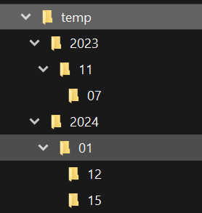

- You are given a REST API which accepts POST requests for daily pricing timeseries data. The request should include a date range, a product name and one or more metrics (e.g. price). The API response is in JSON format (see attached sample response)
  - Write a client interface to query the REST API and return results in a pandas dataframe. Think of error handling and performance.
  - Use your client interface to query the rate for 2 products (EURUSD and EURGBP) and write functions to perform the following:
    - implied GBPUSD rate
    - rolling standard deviation for one series with a parametrized window (e.g. 10 day)
  - Use the response for the sample ticker and the following definitions for this part of the question:
    - PL(T) = Price(T) - Price(T-1)
    - CumulativePL(T) = sum(PL(S)) over all S <= T.
    - Drawdown(T) = CumulativePL(T’) - CumulativePL(T)
where T’ maximizes CumulativePL for T’ <= T.
Print the following:
- Date of the maximum drawdown.
- Date when the drawdown began.
- The annualized Sharpe Ratio.

